Smoking Detection

(Phase 3)

Students

|  |  |
| --- | --- |
| Amro abdelqader | 202110238 |
| Ayham Al-Tamimi | 202210239 |
| Braa Abu Safi | 202110067 |

# Abstract

This report will discuss the steps we follow to use YOLO (You Only Look Once) to detect smokers by using the camera, firstly we collect images of smokers and non-smokers people from different sources then we use LabelImg (graphical image annotation tool) to give the cigarette object a class after that we train the YOLO, we used OpenCV to detect the smokers by using a camera.

Contents

Abstract 2

Introduction 2

Work Details 2

Conclusion 6

# Introduction

Our Jordanian community suffers from the widespread habit of smoking among its citizens, our model will detect the smokers in the cameras.

# Work Details

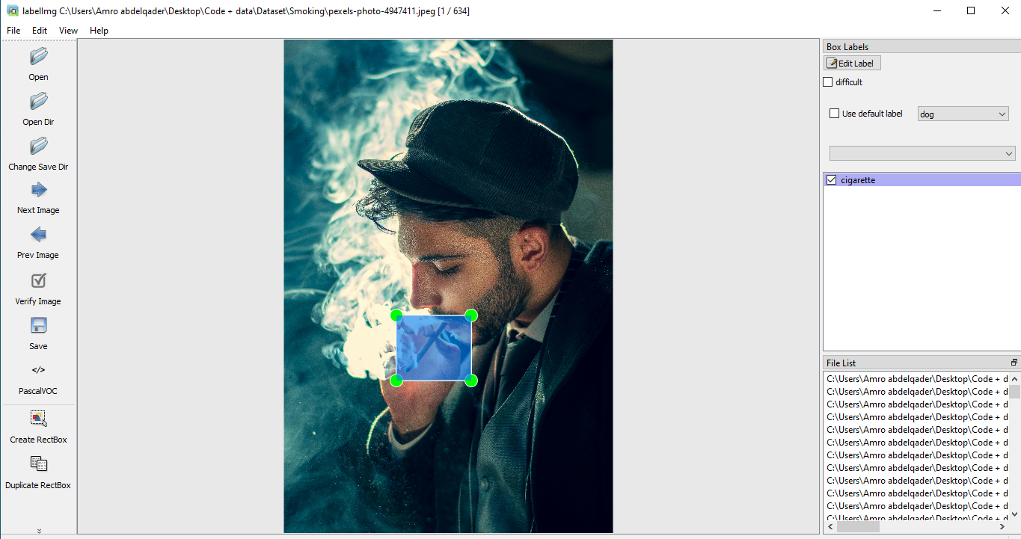

First, we used LabelImg to give cigarette objects a cigarette class.

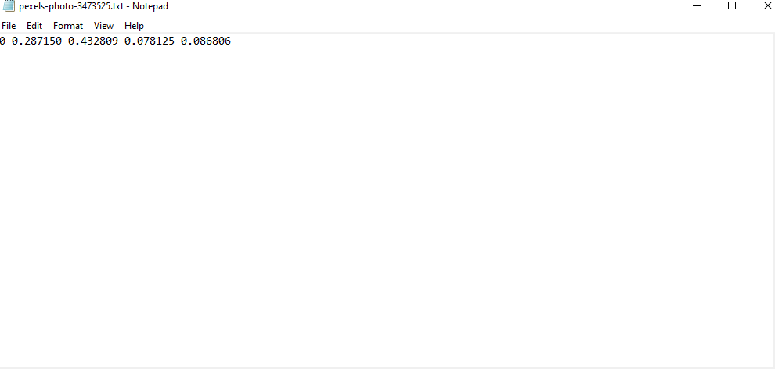

The LabelImg will give us a text file containing the box coordinates, and the class.

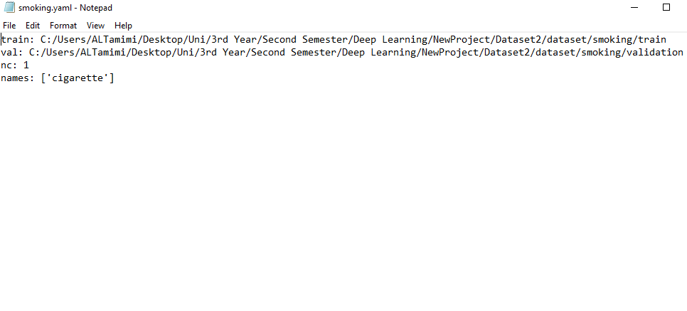

Here we made a yaml file which includes the path to the train set and validation set, class names, and number of classes.



Here we train the YOLO by giving the path to the YAML file and the number of epochs.

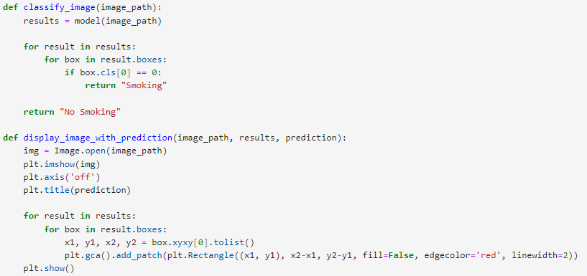

Here we built two functions, first the classify_image gives the class Smoking for object 0 else class no smoking.

The display_image_with_prediction to display the images with its class.

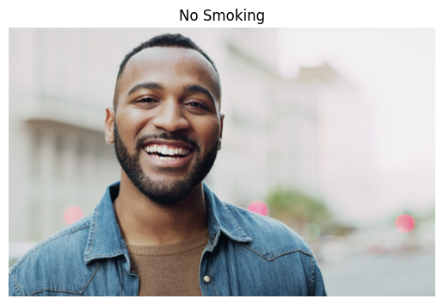

Here we test the model.



Here we get the model's best weights.



Initialize face detector.



Open webcam.

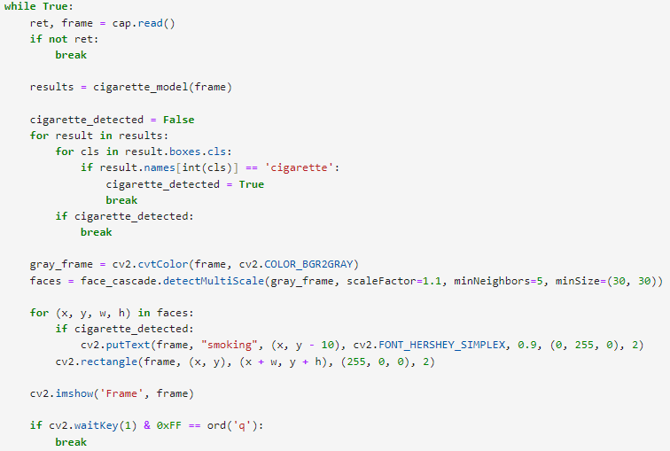

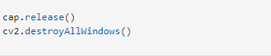

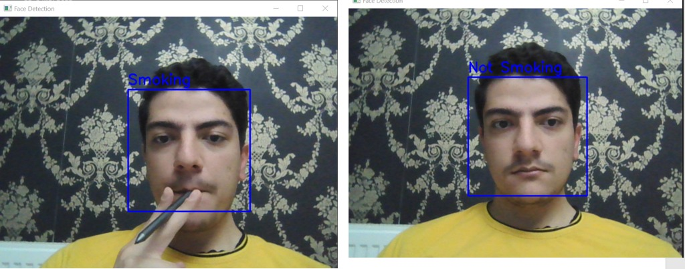

# 

# Conclusion

We used Yolo to detect smokers by using the camera, yolo (you only look once) divides the image/frame to 4x4 sections usually and checks if each section has an object inside of it and shows every section as a vector. The first value in the vector shows whether this section has an object to be detected or not, the next 4 values show the coordinates of the label, and the last value/s shows if any of our objects are present in that section of the image. All vectors are then processes once with one forward pass, hence the name you only look once.